**PROFESSIONAL TRAINING REPORT**

**Sathyabama Institute of Science and Technology**

**(Deemed to be University)**

*Submitted in partial fulfillment of the requirements for the award of Bachelor of Engineering Degree in Computer Science and Engineering*

*By*

***P.PRADEEP AADITHAN***

***Reg.No:40110975***



# **DEPARTMENT OF COMPUTER SCIENCE AND ENGINEERING SCHOOL OF COMPUTING**

**SATHYABAMA INSTITUTE OF SCIENCE AND TECHNOLOGY JEPPIAAR NAGAR, RAJIV GANDHI SALAI,**

# **CHENNAI - 600119, TAMILNADU**

#### OCT2O22

SATHYABAMA

INSTITUTE OF SCIENCE AND TECHNOLOGY

(DEEMED TO BE UNIVERSITY)

Accredited with Grade “A” by NAAC

(Established under Section 3 of UGC Act, 1956)

JEPPIAAR NAGAR, RAJIV GANDHI SALAI, CHENNAI— 600119

[www.sathyabamauniversity.ac.in](http://www.sathyabamauniversity.ac.in/)

**DEPARTMENT OF COMPUTER SCIENCE AND ENGINEERING**

BONAFIDE CERTIFICATE

DNV G



This is to certify that this Project Report is the bonafide work of **P.PRADEEP** **AADITHAN** (40110975) who carried out the project entitled **“ToDo WEB** **APPLICATION“** under my supervision from Aug 2022 to Oct 2022.

#### **Internal Guide**

DR.S.VIGNESHWARI,M.E

**Head of the Department**

DR.S.VIGNESHWARI,M.E,PH.D

DR.L. LAXSHMANAN,M.E.,PH.D

**Submitted for Viva voce Examination held on**

**InternalExaminer ExtemalExaminer**

**DECLARATION**

*I,****PRADEEP AADITHAN.P*** *hereby declare that the Project Report entitled* ***“ToDo WEB******APPLICATION****" Done by me under the guidance of* ***Dr. S.VIGNESHWARI*** *is submitted in partial fulfillment of the requirements for the award of Bachelor of Engineering degree in Computer Science and Engineering.*

**DATE:**

#### **PLACE:**

PRADEEPAADITHAN.P

## **SIGNATURE OF THECANDIDATE**

**ACKNOWLEDGEMENT**

*I am pleased to acknowledge my sincere thanks to Board of Management of* ***SATHYABAMA*** *for their kind encouragement in doing this project and for completing it successfully. I am grateful to them.*

*I convey my thanks to* ***Dr. T. Sasikala M.E., Ph.D.,*** *Dean, School of Computing ,* ***Dr.S.Vigneshwari M.E., Ph.D., and Dr.L.Lakshmanan M.E., Ph.D.,*** *Heads of the Department of Computer Science and Engineering for providing me necessary suppon and details at the right time during the progressive reviews.*

*I would like to express my sincere and deep sense of gratitude to my Project Guide* ***DR.S.VIGNESHWARI*** *for his valuable guidance,suggestions and constant encouragement pavedwayfol he successful completion of my project work.*

*I wish to express my thanks to all Teaching and Non-teaching staff members of the Department of Computer Science and Engineering who were helpful in many ways for the completion of the project.*

**ABSTRACT**

*ToDo is a web application that can be used to store pending works and make it easy for users.*

***Usage :***

* *HTML*
* *CSS*
* *PHP*
* *Bootstrap*
* *MySQL*
* *Xampp Control Panel*
* *Visual Studio Code*

*Xampp control panel is a management tool that offers to supervise the actions of individual components of XAMPP. The development environment can only be used when Apache and MySQL are in running state .*

*This project uses a browser (chrome) since it’s a live application . Since this project includes sql and connected with a database created in Xampp control panel , the Apache and MySQL should be in running .*

**TABLE OF CONTENTS**

|  |  |  |
| --- | --- | --- |
| **CHAPTER**  **NO** | **TITLE** | **PAGE NO** |
| 1 | INTRODUCTION | **1** |
| 2 | AIM AND SCOPE OF THE PRESENT INVESTIGATION | **2** |
| 2.1 AIM | **2** |
| 2.2 SCOPE | **2** |
| 3 | EXPERIMENTAL OR MATERIALS AND METHODS; ALGORITHMS USED | **3** |
| 3.1 ALGORITHM | **3** |
| 4 | RESULTS AND DISCUSSION, PERFORMANCE ANALYSIS | **18** |
|  | 4.1 RESULT |  |
| 5 | SUMMARY AND CONCLUSIONS |  |
|  | REFERENCES |  |
|  | APPENDIX |  |
|  | SCREENSHOTS |  |

**LIST OF ABBREVATIONS**

**ABBREVATION EXPANSION**

1.**HTML -** *HYPERTEXT MARKUP LANGUAGE*

2**.CSS** - *CASCADING STYLE SHEETS*

**3.PHP** - *HYPERTEXT PREPROCESSOR*

**4.MYSQL -** *MY STRUCTURED QUERY LANGUAGE*

**CHAPTER 1**

**INTRODUCTION**

**Bootstrap**

*Bootstrap is a free and open-source web development framework. It’s designed to ease the web development process of responsive, mobile-first websites by providing a collection of syntax for template designs. Bootstrap is an open and free HTML, CSS and JS toolkit that is used by web developers to create responsive website designs quickly and effectively.*

**XAMPP Control Panel** 

***XAMPP Control Panel****is a management tool that offers to supervise the actions of individual components of XAMPP.One can use the Control Panel to determine whether Apache, MySQL, Mercury, etc. are currently in function or not. The development environment can only be used when Apache and [MySQL](https://www.javatpoint.com/mysql-tutorial)are in running state. The XAMPP Control Panel icon exists in the system tray. It is an orange-colored icon that is visible when Panel is in running state. XAMPP Control Panel is the easiest way to manage all your web servers. This control panel is available in the root directory of the server and can be accessed from the Windows start menu.*

**CHAPTER 2**

**AIM AND SCOPE**

**2.1 Aim :**

*To develop a web page , displaying a todo list with necessary features .*

**2.2 Scope :**

* *Currently applications like ‘keep notes’ in android and ‘sticky notes’ in windows are in use for storing user’s data generally .*
* *But this web application is developed specifically to store user’s work details that need to be done along with priority .*
* *Hence , can help users to be more specific and clear about their own works .*

**CHAPTER 3**

**3.1 METHODS OR ALGORITHM USED**

*Method implemented to develop this web application is live server .*

*Coding being done in visual studio code , keep updating the display of output in live server ( chrome ) .*

*At the same time , apache and MySQL must be in running state so that PHP and MySQL included in coding part can be executed .*

1. *Create an account in Xampp control panel .*
2. *Create a database using the same account .*
3. *Connect the user account and the database with the coding in Visual studio code .*

*For further details ,* [*click here*](https://blog.udemy.com/xampp-tutorial/)

**CHAPTER 4**

**4.1 RESULT AND DISCUSSION**

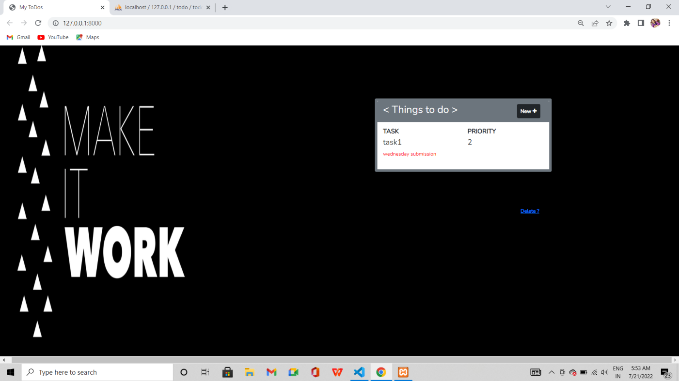

**CHAPTER 5**

**5.1 SUMMARY AND CONCLUSION**

*Thus , a web application has been developed specifically to store one’s work details . Priority column helps users to plan things accordingly . This makes todo web application completely different from others .*

**REFERENCES**

1. [***https://blog.udemy.com/xampp-tutorial/***](https://blog.udemy.com/xampp-tutorial/)
2. [***https://www.w3schools.com/bootstrap/***](https://www.w3schools.com/bootstrap/)
3. [***https://locallhost.me/phpmyadmin***](https://locallhost.me/phpmyadmin)
4. [***https://www.tutorialspoint.com/php/index.htm***](https://www.tutorialspoint.com/php/index.htm)

**CHAPTER 6**

**6.1APPENDIX**

*A database named ‘todo’ is created on xampp server with a table called ‘todolist’ which has columns for ‘id’ , ‘title’ , ‘description’ , ‘deadline’ (priority) .*

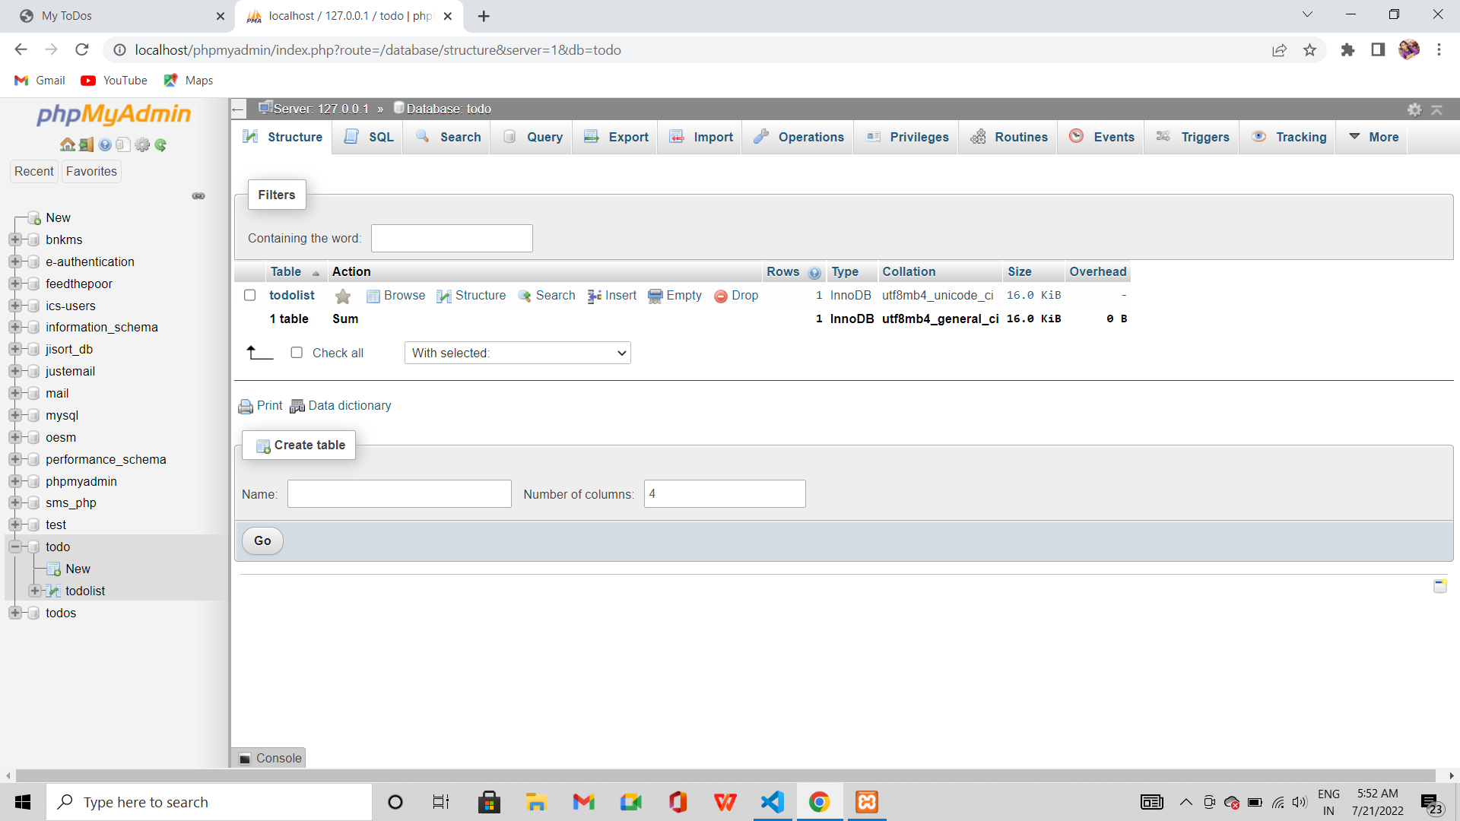

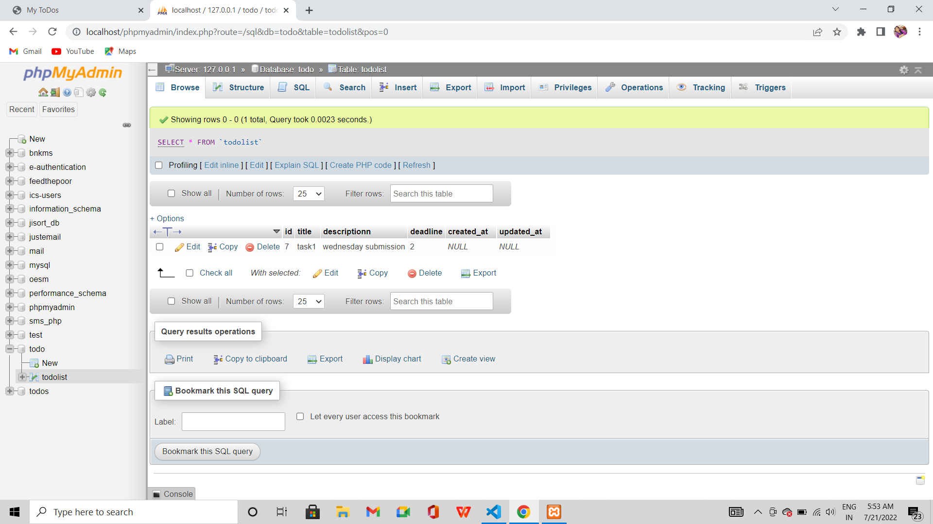

**ToDo web application index page :**

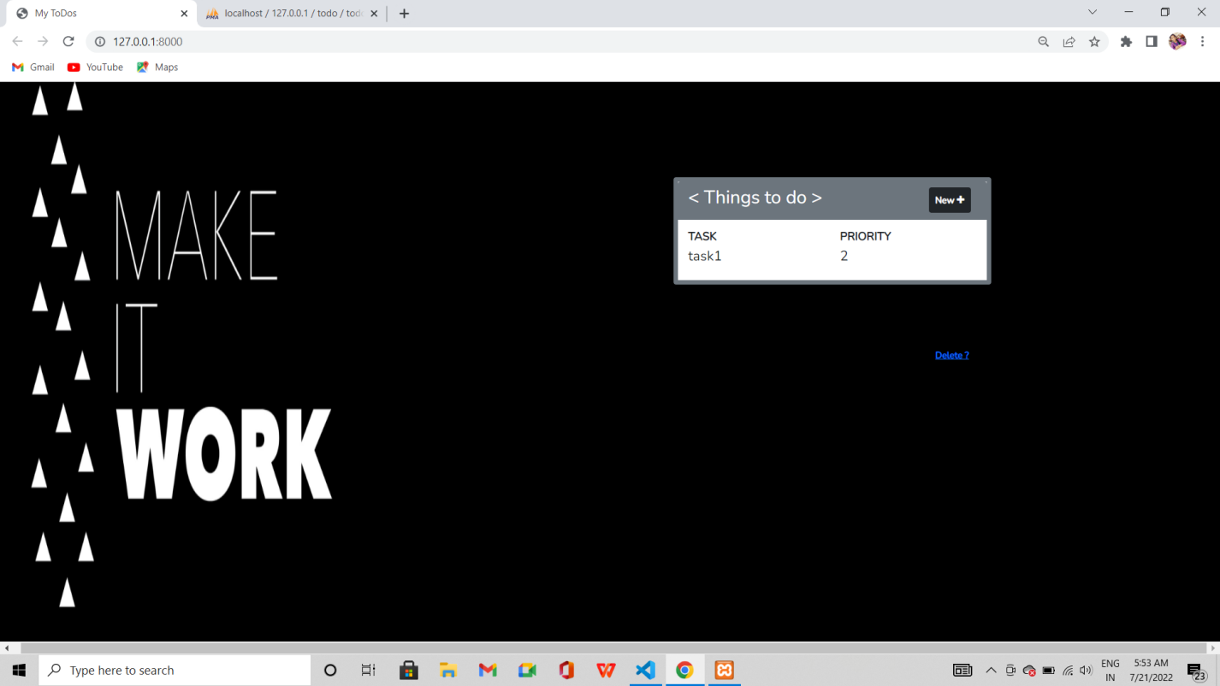

*When cursor hovers on the task title , description of respective task gets displayed as shown below .*

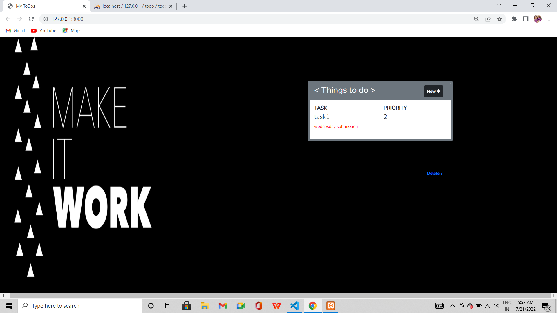



**Use of ‘New+’ button**

*This button is used to add a task to the ToDo list* ***.***

*It displays a form as shown below and works as follows .*

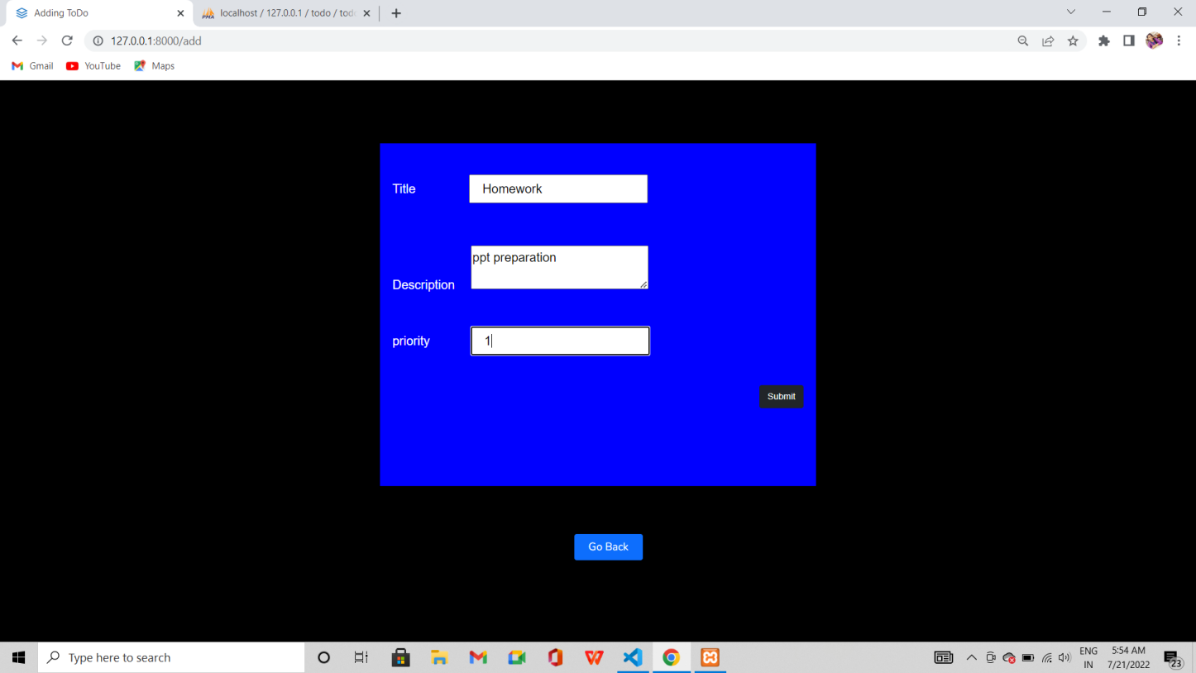

*‘Go Back’ button is available to go back to the index page without adding the task .*

*Whereas when ‘submit’ is pressed after filling the form , it works as follows .*

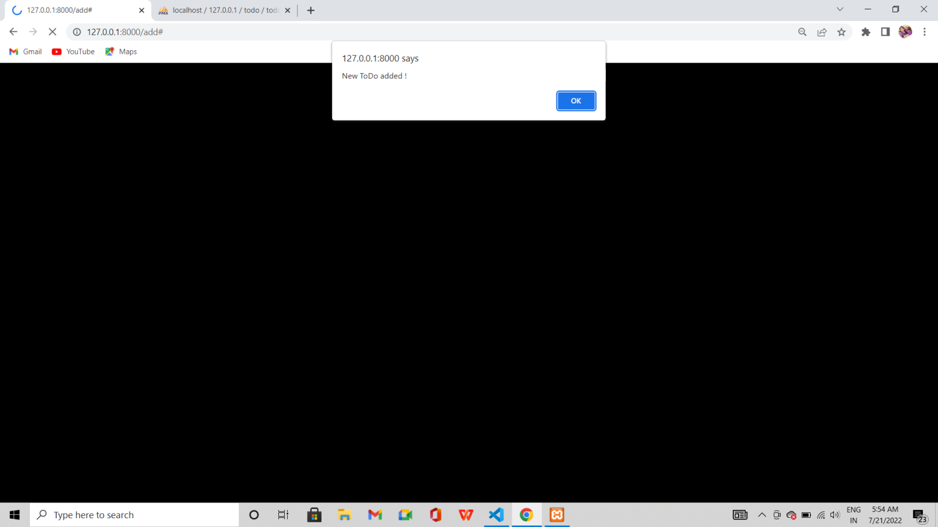

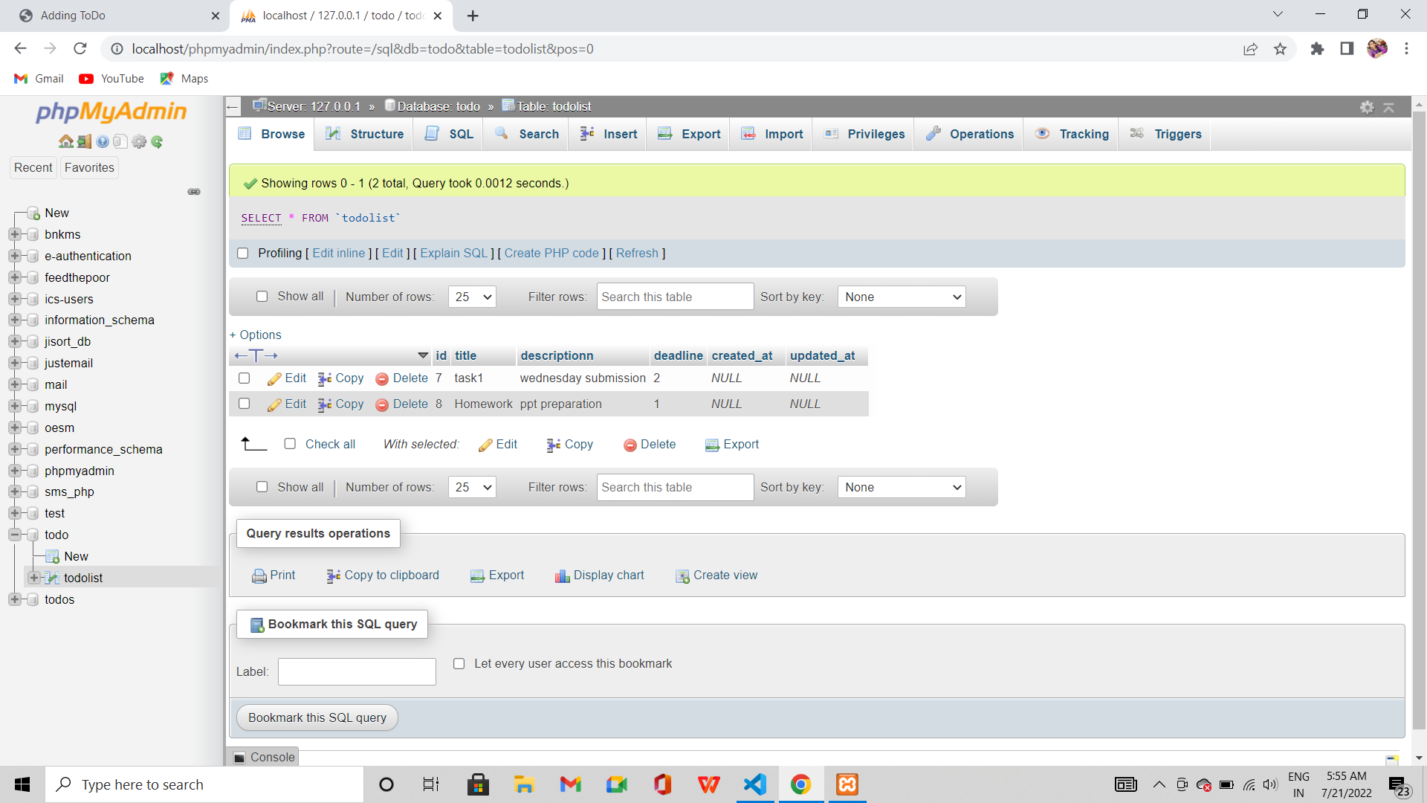

*This operation reflects on database .*



*Thus the filled task data is added to the database in Xampp server .*

*Similarly , ‘Delete’ hyperlink on main page do as follows .*

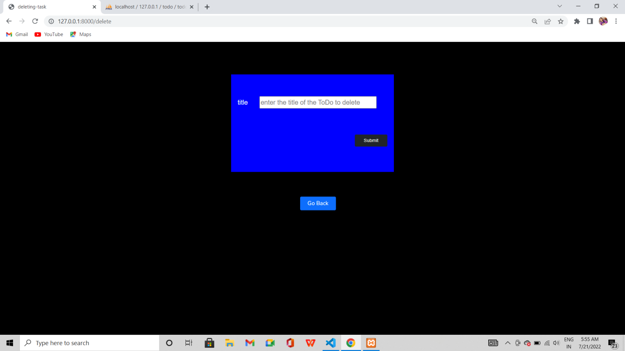

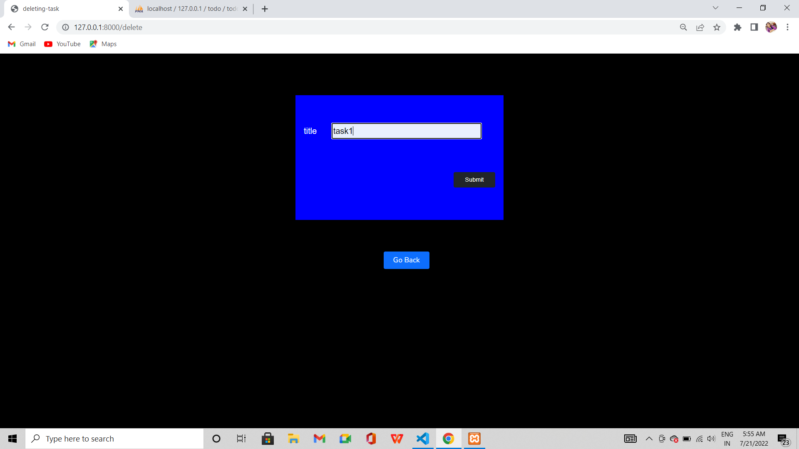

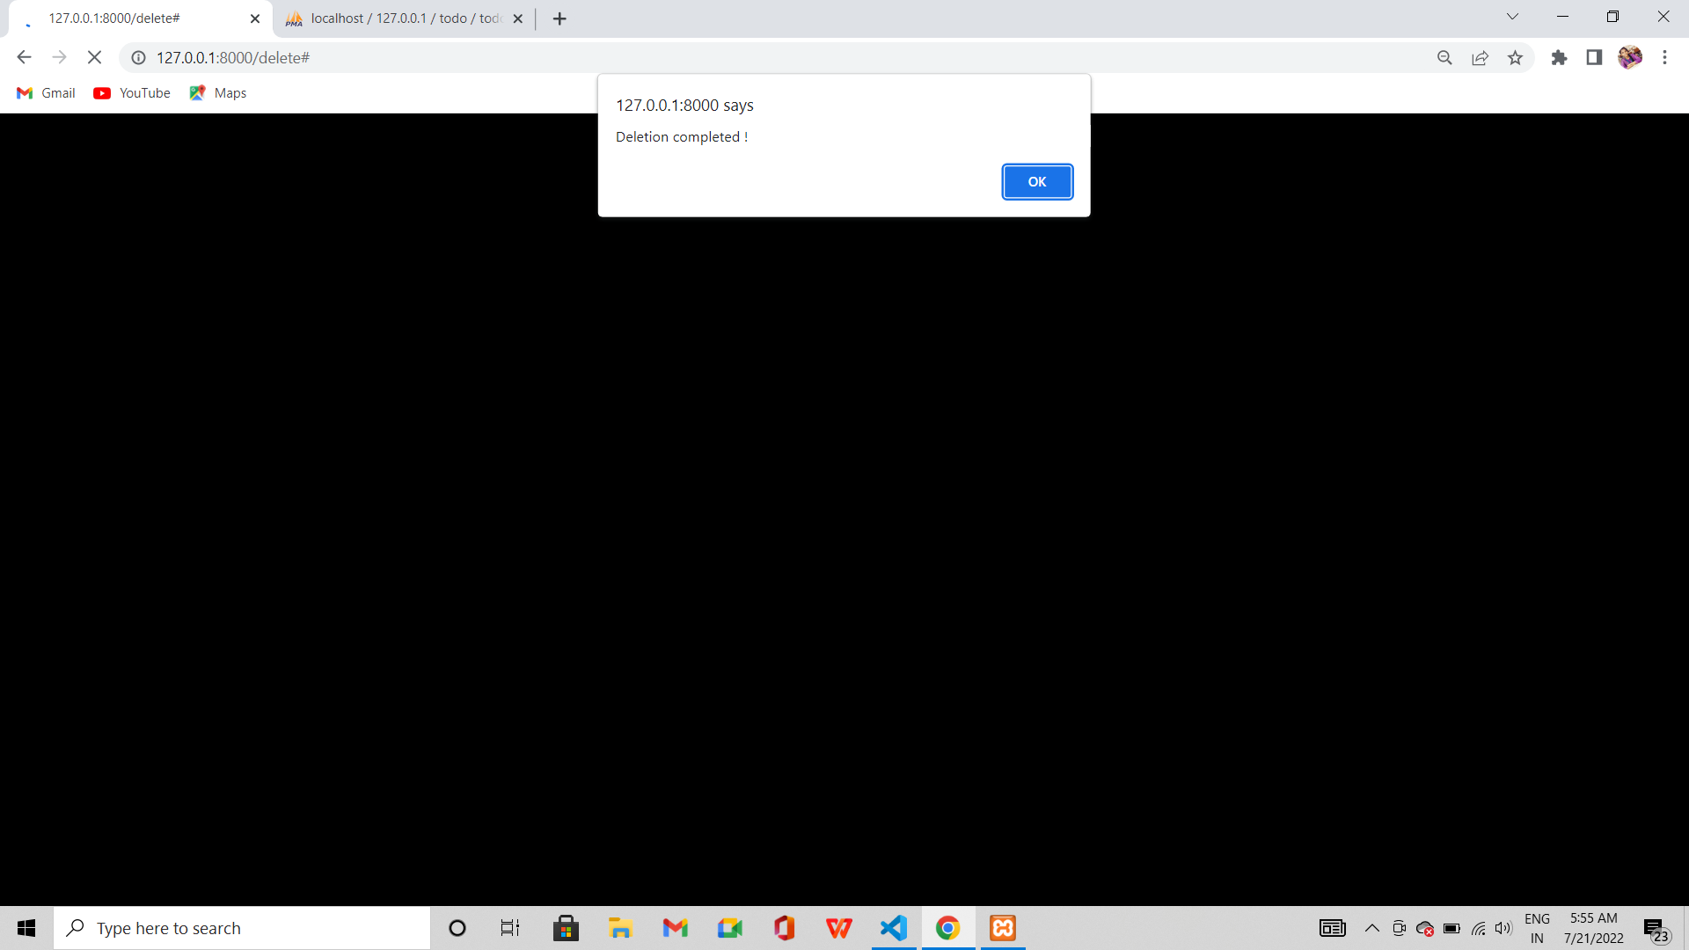

*See , the task mentioned on delete form has been deleted from the database* 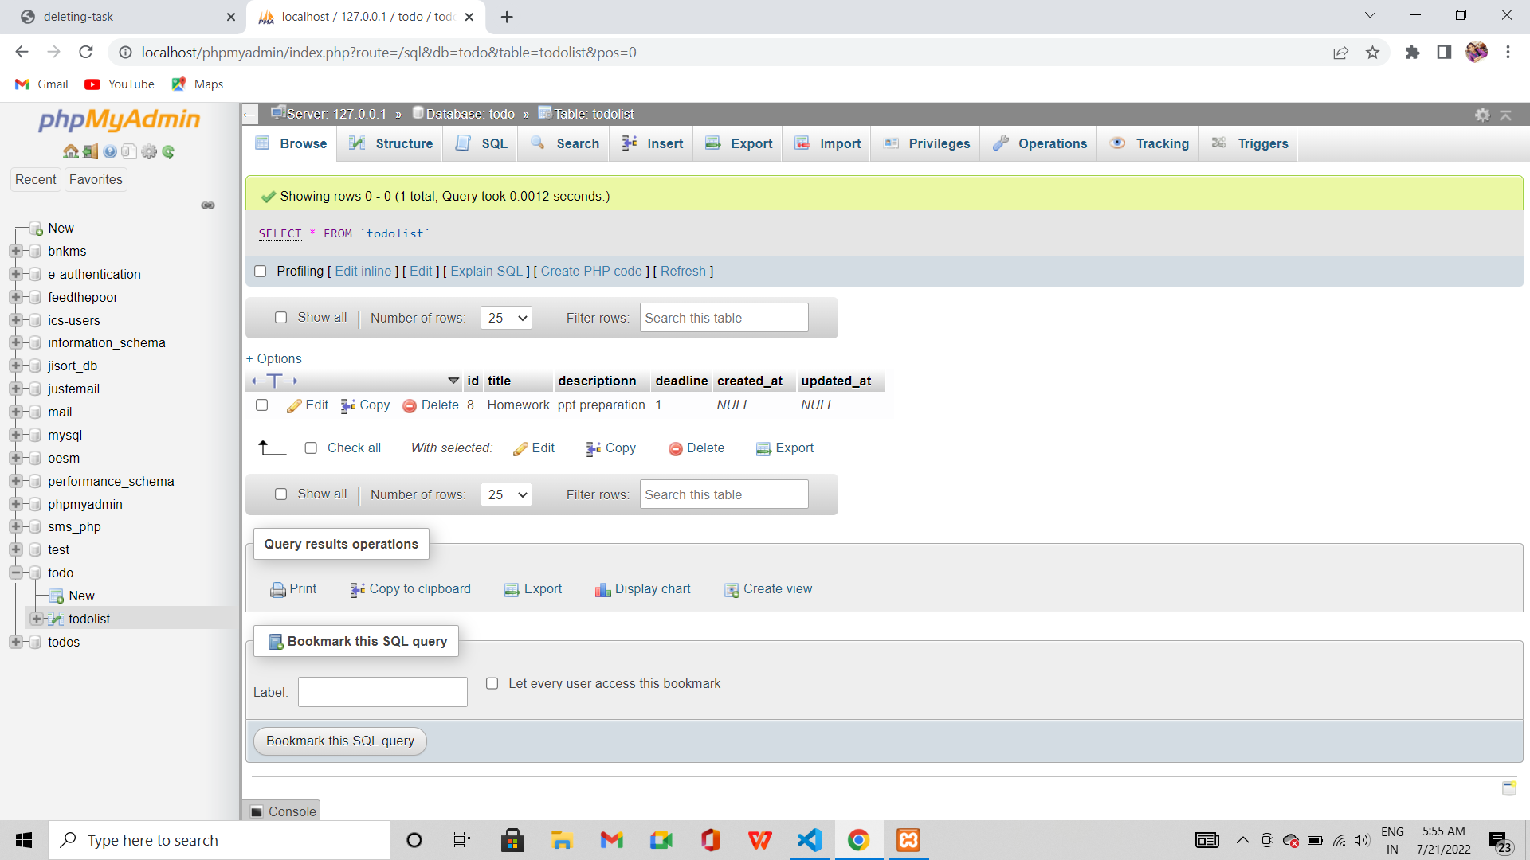



*What if we give a task title that wasn’t present in the database itself to delete .*

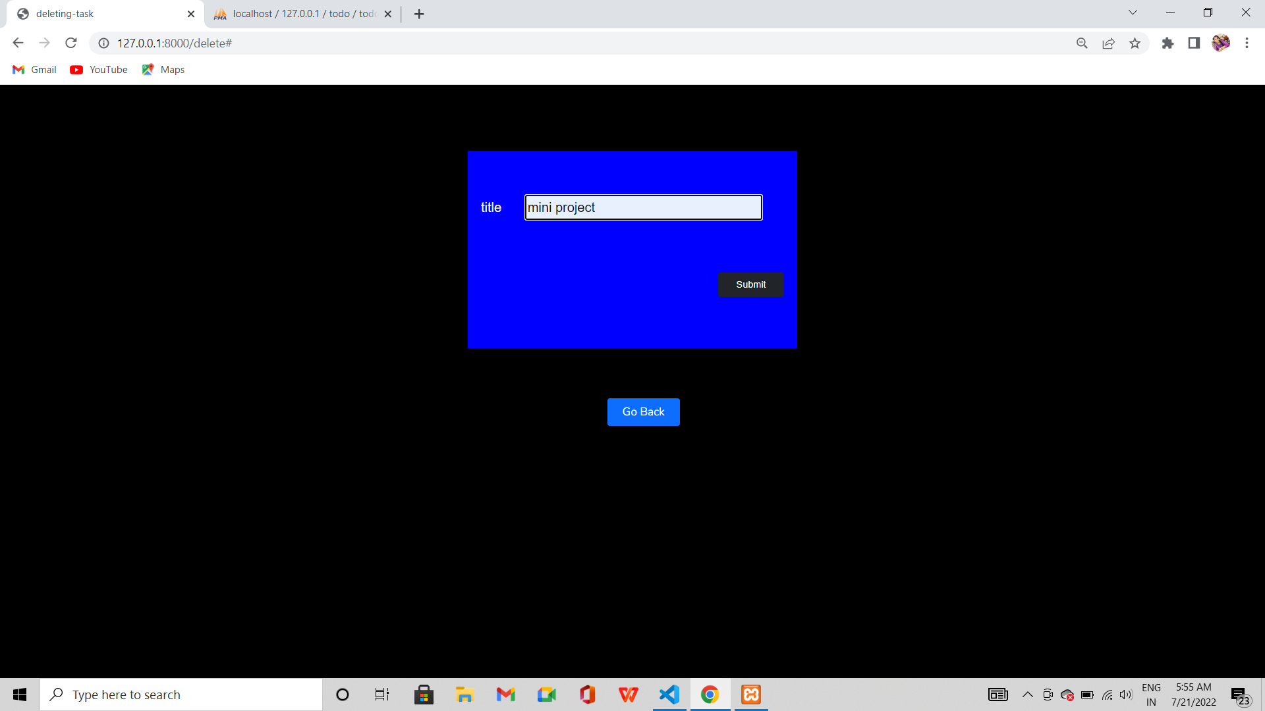

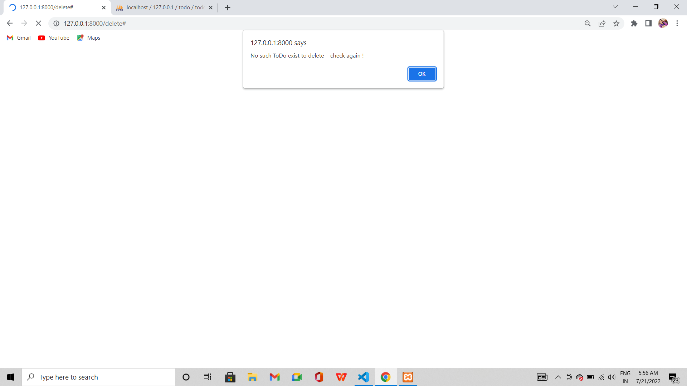

**The index page right now :**

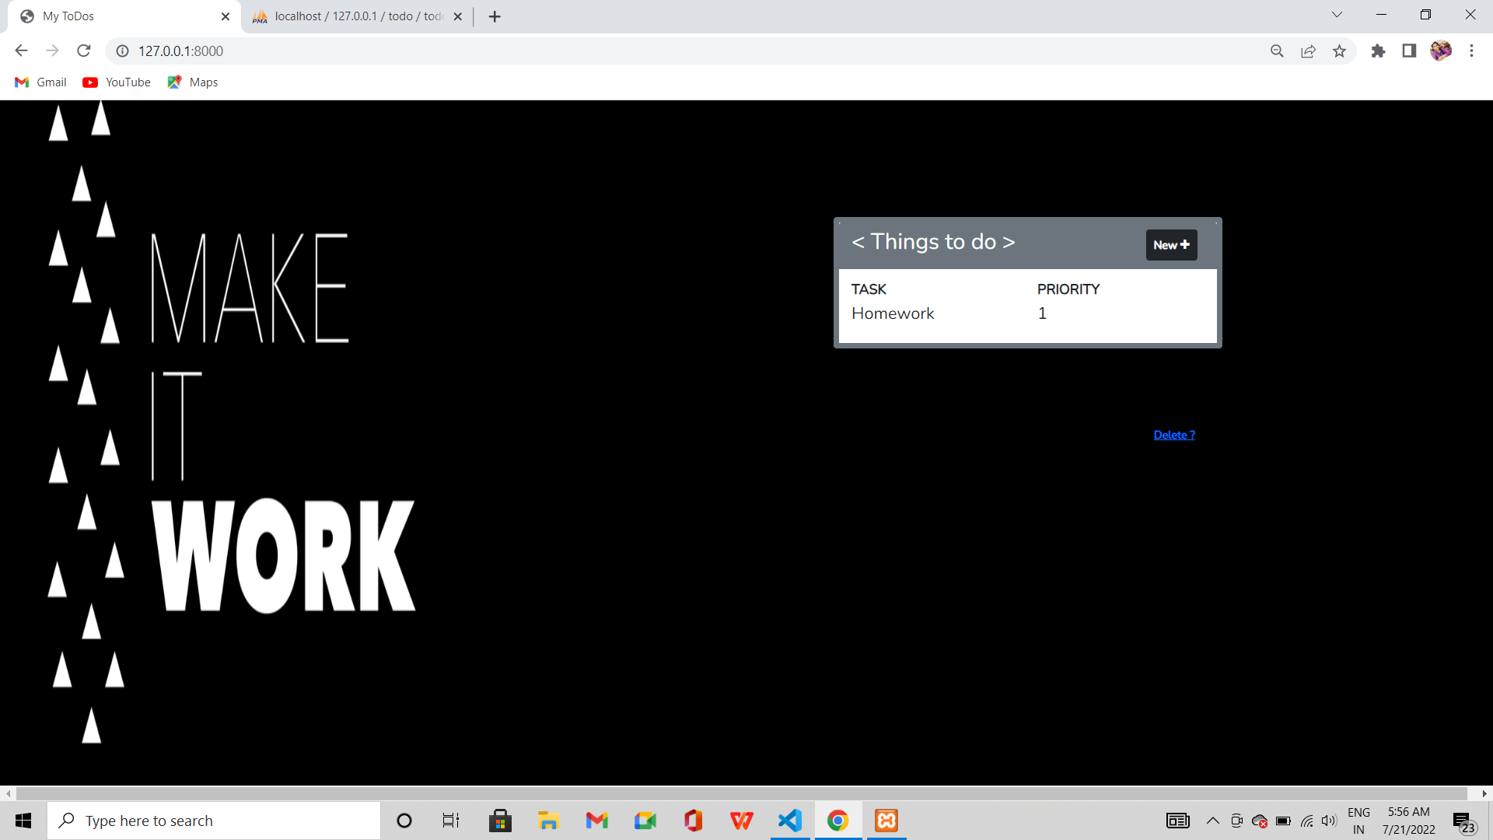

*This ToDo displays displays whatever present in the ‘todolist’ table in todo database .*





